Monthly Clearance
This is to certify that EZE Ernest Chibueze with state code No: OY/25C/5371 and NYSC Call-up No: NYSC/FUW/2025/291616 has worked satisfactorily for the month of April, 2026 and should be paid monthly allowance for the month of May, 2026.
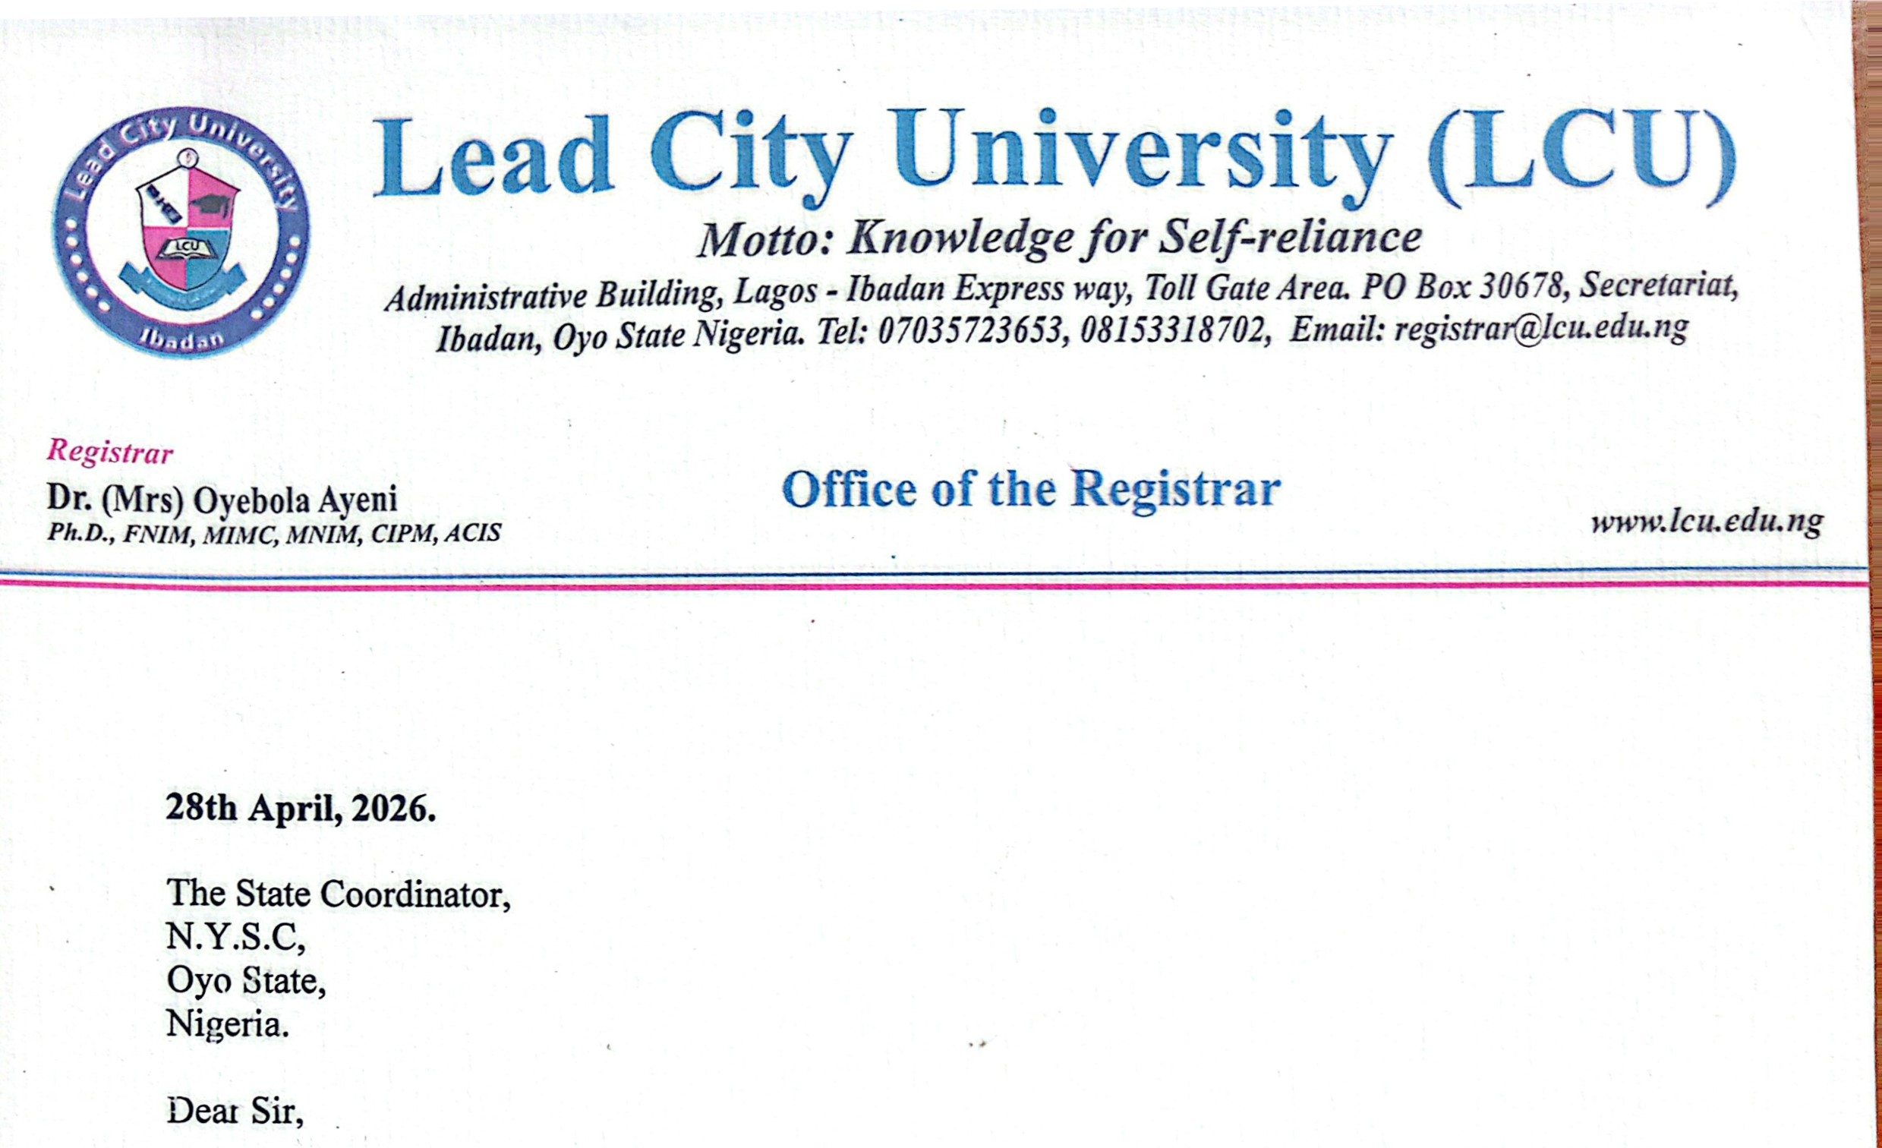
Thanks you.
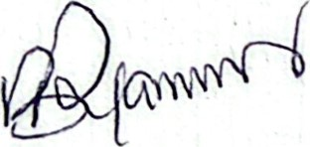
A. O. Äyanjompe (Mrs.)
Deputy Registrar, HR (Admin/Tech. Est.)
For: Registrar

